Consortium POUR LA RECHERCHE ECONOMIQUE ET SOCIALE

DOCUMENT DE RECHERCHE

(VERSION PROVISOIRE)

Catastrophes and poverty in developing countries

Abdoulaye Diagne
Octobre 2015

Introduction
The negative impacts of climate change on the natural and human environment are generally considered as a global problem (IPCC, 2007). Climactic disasters affect both developed and developing countries, with particularly high impacts on the second of these. From 1980 to 2012, losses linked to catastrophes totalled 3800 billion dollars across the world (World Bank, 2013). The consequences of climate change manifest themselves differently from one region to another. The warming of the climate causes, for example, the melting of ice, with some regions having to deal with rising seas. In other regions, the effects of climate change are manifest by extreme meteorological phenomena such as droughts and coastal storms as well as strong rains which lead to floods. According to an OECD report (2012), the number of persons exposed to floods annually will increase from 1.2 billion to 1.6 billion between now and 2050. While in rural areas, they may be synonymous with better future harvest due to greater availability of water for agriculture or more pastureland for livestock, in urban areas, floods are experienced in the form of destroyed homes, propagation of illness, loss of employment or interruption of schooling. In an environment with high vulnerability and poverty, the impacts of catastrophes may be enormousand long lasting. In fact, their size depends on the resilience of households and their communities, i.e., their capacity to recover from a shock in a given socio-ecological environment (Folke et al., 2004).
In recent years, a growing interest has been accorded to the relationship between vulnerability, poverty and resilience to climactic shocks in the context of developing countries. The assumption which generally underlies these works is that climate change aggravates the vulnerability of poor populations and therefore decreases their resilience to these shocks (Cannon, 2008; Galderisi et al., 2010). In this context, Berg (2009) evaluates the impact of Hurricane Mitch on survival strategies of rural households in Nicaragua. He shows that this natural catastrophe can push those with more highly remunerative assets to choose more defensive strategies to allow their survival, but they nevertheless find themselves worse off than before the catastrophe. These results are reinforced by those of Carter M.R. et al. (2007) who are interested in the circumstances within which climactic catastrophes can push households into a poverty trap that they cannot exit from. Studying rural aeras in Ethiopia and Honduras, t Ethiopia and Honduras hey show that the poorest households adopt costly strategies in terms of wellbeing in facing the effects of natural shocks.. . Arouri, Cuong and Youssef (2014) evaluate the impact of natural catastrophes on wellbeing and poverty of rural households in Vietnam. Their results show that storms, floods and droughts negatively impact both the income and the expenditures of the households. They also show that access to credit, internal transfers and social transfers contribute to making households more resilient to natural catastrophes. In a study on rural socioeconomic resilience in a coastal community which is subject to cyclones in Bangladesh, Akter and Mallik (2013) obtain results which suggest that the poor are most vulnerable and that they suffer from much higher economic, physical and structural prejudice. However, this high vulnerability does not necessarily lead to a lower resilience. This conclusion refutes the assumption that vulnerability is the opposite of resilience. Another tendency in the literature is to evaluate the efficacy of strategies implemented by households or communities to adapt to sustained changes caused by hydrometerological phenomena (Youspef, and al.,2015; Lasage and al., 2014).

The works cited above are microeconomic, and very few of them seek to verify whether the conclusions obtained are valid at the level of entire developing countries. Moreover, in many cases only one type of catastrophe is addressed, whereas often there are two or more disasters hitting a country over a very short time frame, which makes it very difficult to estimate the contribution of each of these chocksto the overall estimated impact.. Finally, the distinction between the long-term effects and the short-term effects is essential. The first of these requires emergency measures whereas the second requires more systemic actions which strengthen the resilience of the negatively affected population. The present study addresses these gaps by bringing new empirical evidence on the impact of catastrophes on poverty in developing countries.
The developments are organized as follows. Section 2 proceeds with a survey of the literature on the impacts of catastrophes on the living conditions of populations and their responses to shocks. Section 3 presents the methodology used to analyse the effects of disasters on poverty. Section 4 analyzes the results of the estimations and section 5 draws the main lessons from the results obtained.

2. Catastrophes and poverty in a context of development: A literature review
While humanity has always had to face natural catastrophes with fairly major socioeconomic consequences, economic research on natural disasters is quite recent. Natural catastrophes were analyzed for the first time as a problem for development by Albala-Bertrand (1993a and b). Earlier works primarily dealt with effective management of catastrophes, and then become more oriented towards adaptation strategies adopted by the victims of these catastrophes (Zapata-Marti, 1997; Hallegatte and Przyluski, 2010, Lazzoroni, 2013) or their socioeconomic impacts on resilience strategies. This second category of works uses a definition of natural catastrophes which is similar to that of Hallegatte and Przyluski (2010):“a natural event that causes a perturbation to the functioning of the economic system, with a significant negative impact on assets, production factors, output, employment, or consumption”.This definition excludes catastrophes cause directly by man (terrorism, war, industrial accidents, etc.) and considers disasters as exogenous factors with impacts on socioeconomic, demographic and institutional characteristics of the localities where they occur. While the exogenous nature of natural disasters can certainly be debated given the influence that humans have on degradation of ecosystems, exogeneity is assumedin the most of works on the economic impacts of natural catastrophes. But studies have adopted different approaches with regard to factors such as: the typology of catastrophes, measurement of the magnitude of shocks, the nature and sources of data used, the geographic coverage, the methodological approach, the type of effects as well as the size of damages.

2.1Typology, measurement of shocks and sources of data
A distinction is commonly made between catastrophes of geophysical origin (earthquakes, landslides,volcanoes) and climactic catastrophes (tornadoes, hurricanes, storms, extreme temperatures, drought, floods). Depending on the origin of the disaster, the literature distinguishes between geophysical (telluric) disasters and hydrometeorological disasters (climactic). Studies on hydrometeorological catastrophes are highly interested in the effects of climate change such has drought and floods on growth in living conditions of populations, primarily in developing countries (Lazzaroni, 2013; Foltz and al., 2013; Giesbert, Schindler; 2012; Hendrix and Salehyan, 2012; Asiimwe andMpuga, 2007). For catastrophes of geophysical origin, most of the works deal with socioeconomic impacts of seismic activity (including tsunamis), landslides or volcanic eruptions (Kellenberg et al., 2008; Data et al., 2013; Felbermayr and Gröschl, 2014; Cavallo et al., 2012). In addition to its origin, the magnitude is also a criterion in the classification of disasters. Some authors have worked on the impact of specific major catastrophes. Hoddinott and Kinsey (2001) have for example evaluated the impact of the major drought that occurred in Zimbabwe on growth of children, and Baez and Santos (2007) evaluated the impact of Hurricane Mitch on Nicaragua in October 1998 on the health and nutrition of children and labour market participation. To identify major catastrophes, some authors use percentiles and other use z-scores (gap relative to standardized average) of damages. For example, it is generally acknowledged that major catastrophes are those with a z-score greater than 2. It should be highlighted that works on specific major catastrophes are relatively older, most of them having been produced before 2000. The recent literature deals more with small and medium catastrophes and tends to evaluate the impact of a series of catastrophes rather than focusing on just one (Kellenberg et al., 2008).
Once the type of natural catastrophe has been identified, the question of how to measure them must be tackled. Three approaches are most commonly followed. The first evaluates the magnitude of disaster using direct damages in terms of the number of persons killed, the persons affected and economic losses (Noy and Bang Vu, 2010; Kellenberg et al., 2008). Thus, many catastrophes which are different in nature can be compared on the basis of their consequences. For annual estimations, some authors such as Noy and Bang Vu (2010) used weights to account for the month that the catastrophe occurred in and to avoid overestimation of damages. The weight is lower the further into the year the disaster occurred. A second way to evaluate disasters magnitude consists of basing it on their occurrence. Many authors simply measure shocks by a dummy variable which takes a value of 1 if the shocks occurs and 0 otherwise (Kellenberg et al., 2008; Combes and Ebeke, 2011; Lazzaroni, 2013) while others prefer to use their frequency (Lazzaroni, 2013). The third way to evaluate natural shocks consists of measuring their intensity with geophysical or metereological data (magnitude for geophysical catastrophes, wind speed for cyclones, etc.) and not their direct consequences. Felbermayr and Gröschl (2014) showed that using geophysical or metereological data makes it possible to correct for selection bias and to obtain the effects of natural catastrophes on the growth in poverty which are both more statistically significant and larger in magnitude. For hydrometerological catastrophes, direct measures primarily deal with climactic changes. Cullen and Idean (2012) evaluated the impact of climactic changes on social conflicts in Africa by taking as an indicator the standard deviation of climactic changes between the pluviometry of the year considered and that of the long-term trend. Variability of precipitation was also used by Asiimwe and Mpuga (2007) to analyze the effects of pluviometric shocks on income and household consumption in Uganda. Foltz, Gars, Ozdogan, Simane and Zaitchik (2013) did the same to analyze the relationship between climate and wellbeing in Ethiopia.
It is mostly the availability of data that determines the measure of the shock used. For the source of data, almost all of the works on natural catastrophes uses the EM-DAT database of the Centre for Research on the Epidemiology of Disasters(CRED - Centre de recherche sur l’épidémiologie des catastrophes naturelles) of the Université Catholique de Louvain. This database registers catastrophes which occurred after 1900 and are classified according to their type (biological, climactic, geological, hydrological and meteorological) and their consequences in terms of persons killed, persons affected and economic losses. For a catastrophe to be registered in the database, it has to fulfill at least one the following criteria: official count of at least 10 deaths, official count of at least 100 persons affected; a call for international aid; or a declaration of a state of emergency. The information is collected from sources such as humanitarian institutions (UN agency or NGO), research institutes, press agencies and in particular insurance companies. Both free access to the EM-DAT database and its large coverage across countries and types of catastrophes have certainly contributed to its almost universal use in research.

However, this approach has some limitations which reside in estimation of damages. Given that most of the information used is provided by insurance companies, only disasters covered by their contracts are included (selection bias), and only damages enclosed in these contracts are evaluated (coverage bias). In addition to coverage and/or selection bias, use of the EM-DAT data in the estimation introduces another major problem (Felbermayr and Gröschl, 2014). Since losses are higher in developed countries, there is a positive correlation between GDP per capita and the measure of intensity of catastrophes based on the economic size of damages. This correlation poses endogeneity or multicolinearity problems in the estimations of the relationship between economic growth and shocks. To correct for this bias, Felbermayr and Gröschl (2014) has put together, using information from geophysical and metereological sources, an alternative database on natural catastrophes measured by physical magnitude and covers the 1979-2010 period. Usingthis database (which they named GEOMAT) in the econometric estimations, results findmore strongly negative impacts of catastrophes on economic growth.
In terms of geographic coverage, works on impacts of natural disasters can be distributed into three categories. The first concerns works performed at the micro scale on specific countries with individuals or households as the unit of observation (Data et al., 2013; Giesbert and Schindler, 2012). These mainly deal with African countries and are interested in the impacts of catastrophes on the wellbeing of households living in rural areas as well as on the subsistence strategies that these household adopt to face natural shocks (Foltz, Gars, Ozdogan, Simane, Zaitchik, 2013; Giesbert and Schindler, 2012; Data et al., 2013). Other studies are at a meso-economic level and study the links between natural disasters and economic aggregates relating to territorial areas such as states in a federal country, provinces or communities. For example, Noy and Bang Vu (2010) are interested in the effects of natural disasters on production in Vietnam using panel data at the provincial level. Similarly, Rodriguez-Oreggia et al. (2012) analyzed, at the municipal level, the effects of natural catastrophes on the level of human development and poverty in Mexico. The third category includes studies that both involve many countries and use either household survey (Mohapatra et al., 2009) or macro-economic aggregates (Kellenberg et al., 2008; Hendrix and Salehyan, 2012). The meta-analyzes fall into this third category (Lazzaroni and van Bergeijk, 2013). These studies are primarily interested in the impact of disasters on economic growth in developing counties (Felbermayr and Gröschl, 2014; Cavallo et al., 2012). Other studies are specifically interested in African countries to see whether some link exists between natural catastrophes and the recurrence of socio-political conflict (Hendrix and Salehyan, 2012).

2.2. Transmission channels and impacts
Catastrophes may aggravate poverty in many ways. One of the most obvious is the immediate loss of labour income due to death or disability. If the deceased person played an important role in providing productive labour (or income) as a part of the household, loss of this resource can exert immediate pressure on the capacity of the household to maintain consumption or to accumulate assets. Thanh et al. (2006) produce a longitudinal study on Vietnamese households and show that disability caused by injury is an important factor of poverty. An injury increases the probability of falling into poverty and decreases the probability of exiting poverty.
Another channel that was discussed is the influence of catastrophes on poverty and consumption following the destruction of goods (Berloffa and Modène, 2013; Dercon, 2004; Jakobsen, 2012; Mechler, 2009; Morris et al., 2002; Narayan, 2003). Catastrophes destroy assets and negatively impact investment in assets (Carter et al., 2007). A certain number of studies show that for the poorest household, catastrophes have a disproportionate impact on their consumption: it is most important for those with limited access to the labour, insurance and credit markets (Berloffa and Modène, 2013;Carterand al., 2007; Dercon, 2004; Jakobsen, 2012; Morris et al., 2002; Sawada and Shimizutani, 2008; Shoji, 2010). Traditional theory on consumption smoothing suggests that households use their assets to maintain consumption after a negative shock, but the asset poverty trap may reverse this behaviour for those who are near to the poverty trap threshold (Berloffa and Modène, 2013; Carter, et al., 2007; Dercon, 2004; Jakobsen, 2012; Morris et al., 2002; Shoji, 2010).Households which already have low consumption may reduce their consumption following a catastrophe in order to avoid liquidation of their assets.

Infrastructure is another channel through which catastrophes act on poverty. They can destroy both public capital such as roads, electric networks or the water supply. They can have the same effect on private capital, in particular the assets of rural households. By causing material damages to infrastructure and the productive capital stock, catastrophes weaken the capacity of populations to conduct their economic affairs properly. They affect the economy directly or indirectly and most especially the poor who are often very dependent on infrastructure for access to labour markets and goods (Freeman et al., 2003). Social infrastructure such as schools or clinics and hospitals are sometimes partially or completely destroyed by shocks. Such damages to education or health could have long-term repercussions on the capacity of the poor to invest in human capital, making poverty more persistent.

Theland factor is a channel through which natural disasters have direct effects on populations, particularly those who depend on agriculture. Natural shocks, in particular those which have a hydrometerological origin such as drought, flood and poor rainfall not only degrade arable soils but also make pastoral activities more difficult. The advance of a desert, for example, implies a decrease in the amount of arable land and a deterioration in economic returns on this landin a situation where populations of poor countries have not ceased to increase. Certain catastrophes such as tsunamis contribute to salinization of soils which disrupt agricultural activities, particularly for vulnerable rural households which do not have means to adequate adaptation. The decline in economic returns and losses of arable land directly affect the poor andexposure populations to more vulnerability.

Finally, the effects of natural disasters may be amplified or mitigated depending on the resilience capacity of negatively affected populations or communities. In an absence of an adequate resilience strategy, the material and human losses caused by disasters cause more individuals to fall into situations of permanent poverty. However, with a better prevention and adaptation strategy, the victims may recover relatively quickly after the shock and even return to their conditions of the pre-shock period.

2.3 Impacts and magnitude of shocks
The literature on the socioeconomic impact of catastrophes is comprised of three main thrusts. First, the impact may be evaluated by their effects on national economic growth or different sectors of the economy (Benson and Clay, 2004; Vos et al., 1999; West and Lenze, 1994; Noy and Bang Vu, 2010; Felbermayr and Gröschl, 2014; Cavallo and al., 2012). Albala-Bertrand (1993a and b) performed empirical estimations on panel data from 28 countries and 28 disasters. He concluded that the impact of a loss of capital induced by a catastrophe on long-term growth is low, such that a moderate increase in spending may be sufficient to prevent a decline in the production growth rate. Noy and Vu (2010) are interested in the impact of natural catastrophes on economic growth of the states of India over the 1995-2008 period. They also studied heterogeneity in non-food consumption according to the poverty status of households. Cavallo et al. (2012)find that only major catastrophes have a negative impact on growth and that the effect becomes non-significant when controlling for the impact of radical policy post-catastrophe changes such as in the cases of Iran and Nicaragua.Felbermayr and Gröschl (2014) used GEOMAT data and instead found significant and substantially negative impacts of catastrophes on growth. They also conclude that poor countries are most affected by geophysical shocks and that rich countries are more affected by meteorological shocks. While most studies on the economics of natural catastrophes deal with the economic impact of disasters,A second approach to evaluate the impacts of natural catastrophes is to measure their effect on the wellbeing of populations,in particular at the individual and household level. The most commonly used indicators of wellbeing are poverty, vulnerability, household consumption, their income and/or savings, malnutrition measures by anthropometric indices and health indicators (infant or maternal mortality, etc.) (Dercon, 2004; Dercon and Krishnan, 2000; Kazianga and Udry, 2006; Maccini and Yang, 2008). Hoddinott and Kinsey (2001) showed that the drought in Zimbabwe slowed the rate at which the bodies of children were growingby two percentage points. Baez and Santos (2007) also showed that Hurricane Mitch in 1998 in Nicaragua not only altered the health and nutritional status of children but also increased their participation in the labour market. Datarand al. (2013) analyzed the impact of natural catastrophes on health, nutritional status and child vaccinations in rural Indian households. They concluded that natural catastrophes increase the risk of acute illness such as diarrhoea, fever and respiratory illnesses in children under the age of five. Using estimations from a fixed effects panel model, Lazzaroni (2013) found that a 1% increase in the maximum temperature reduced food consumption by 3 to 5 percentage point in Uganda. Foltz et al. (2013)pay particular attention to the effects of climactic changes on the distribution of total consumption among Ethiopian households, divided into food and non-food consumption. They highlight evidence of the link between climate and wellbeing, a relationship which is more pronounced among poor households.

A third trend in the works emphasizes strategies developed by households and individuals to adapt to changes induced by natural disasters, in particular those which are hydrometerological in nature such as floods, droughts and extreme temperatures (Zapata-Marti, 1997: 10-11; Hallegatte and Przyluski, 2010; Lazzoroni, 2013). Many of these studies are performed at a micro level and examine the way that (primarily rural) households deal with shocks as well as their capacity to adapt to the consequences of these.

3. Methodology
Many studies employ models which relate a variable which represents an economic aggregate of household wellbeing with indicator variables of catastrophes as well as control variables. The model is either specified in linear form and is estimated by ordinary least squares (OLS) (Mueller and Quisumbing, 1998)or in a binary form to account for the qualitative nature of the endogenous variable and is estimated by maximum likelihood (Data et al., 2013). But to evaluate the impact of climactic changes on household assets, Giesbert and Schindler (2012) rejected the assumption of a linear specification of the model and instead used a non-parametric estimation using the Local Polynomial KernelRegression method. Many works using panel data resort to fixed effects estimations (Felbermayr and Gröschl, 2014; Hendrix and Salehyan, 2012; Foltz, Gars, Ozdogan; Simane and Zaitchik; 2013; Giesbert and Schindler, 2012). Due to problems of homoscedasticity and autocorrelation of the error terms in the estimation, another trend in empirical works is to use the generalized least squares (GLS) for linear models (Kellenberg et al.,2008). Noy and Bang Vu, (2010) for their part, use the generalized method of moments (GMM) due to the presence of a lagged dependent variable in the model. This makes it possible for them to account for the fact that the magnitude of a catastrophe depends on the initial situation of a household or the country considered. It is possible also to have both short term and long term impacts of disasters. For authors who worked on panel models with discrete endogenous variables, a negative binomial regression is most often adopted. The authors justify their preference for the negative binomial regression over the Poisson regression due to the strong heterogeneity in the data among the countries studied (Kellenberg et al., 2008; Cullen and Salehyan, 2012).

The quasi-experimental approach is also more recently used in the literature on natural catastrophes. The general principal of these methods consists in comparing groups affected by a disaster to another group which was similar before the occurrence of the catastrophe. The comparison of counterfactual group is generally constructed by pairing individuals who belong to the affected group with individuals who are not affected, on the basis of observable characteristics linked to the variable of interest. Essama-Nssab et al., (2007) used thepropensity score matching method to evaluate the impact of a delayed monsoon season and low rainfall on the wellbeing of populations living in rural areas in Indonesia. To limit the arbitrariness in the choice of similar individual statistics and the comparison variable, Abadie and al. (2003) and Abadie and al. (2014) proposed a method to construct a counterfactual based on a set of individuals who were not affected by the catastrophe. The approach consists of using as a counterfactual a synthetic indicator calculated using a linear combination of individuals not affected by the shock. The coefficients of the linear combination are calculated by minimizing the distance between the variable of interest of the individual affected by the catastrophe and that of the synthetic group before the occurrence of the shock. This approach is often used in evaluating the effects of major catastrophes on economic growth (Coffman and Noy, 2009; Cavallo et al., 2012). It can also be used to construct a counterfactual group in order to estimate the effects of a series of medium or small-sized catastrophes occurring in developing countries.

3.1 Evaluation of the net impact of shocks on poverty

Even a synthetic control method is used, we cannot consider the catastrophes as being responsible for the entirety of the gap between the trajectory of poverty in the absence of shocks and the trajectory actually followed by the country. Certain factors may amplify or mitigate the impact of the shocks on poverty. For example, the level of poverty depends on the level of development of a country and past values of its poverty incidence. Other variables considered likely to explain the evolution of poverty in a country should also be accounted for. Also, the following model is estimated.
${ln(p}_{it})=β_{0}+λ_{1}{ln(p}_{it-1})+\sum_{k=1}^{K}{β_{k}X_{kit}+γ_{0}C_{it}+γ_{1}ln({PIB}_{it})+ γ_{2}{ln⁡(PIB)}_{it}^{2}+ϑ_{i}+η_{t}+ϵ_{it}}$ (1)
In the above equation, $p_{it}$ representsthe level of poverty in country i at date t,$p_{it-1}$is its value in the preceding period, $C_{it}$are shocks and $X_{kit}$consists of control variables which determine poverty. The specific impact of a shock is given by$γ$. Accounting for GDP makes it possible to highlight the role of the country’s development level in explaining its resilience against shocks as well as the non-linearity of this resilience. The term $ϑ_{i}$ corresponds to unobservable individual effects, $η_{t}$to unobservable temporal effects and$ϵ_{it}$is a stochastic term.
Estimation of the above model poses two technical difficulties. The first is the presence of specific individual and temporal effects. Introduction of an indicator variable to account for these individual or temporal effects (a “within” or “between” estimator) is no longer appropriate because of the dynamic natural of the model. The second difficulty is linked to the endogeneity of certain explanatory variables for poverty. If this endogeneity is not controlled for, the resulting estimations will be biased. The most appropriate estimation method to overcome these challenges is that of generalized moments (GMM) introduced by Arellano and Bond (1991). The first difference of the GMM estimator is obtained by taking the derivative of equation (1).
${ln(p}_{it})-{ln(p}_{it-θ})=λ_{1}{[ln(p}_{it-1})-{ln(p}_{it-1})]+\sum_{k=1}^{K}{β_{k}{(X}_{kit}-X_{kit-θ})+γ_{0}{(C}_{it}-C_{it-θ})+γ_{1}\left(ln\left({PIB}_{it}\right)-ln\left({PIB}_{it-θ}\right)\right)+ γ_{2}{\left(\ln\left(PIB\right)\right)}_{it}^{2}-{\left(\ln\left(PIB\right)\right)}_{it-θ}^{2})+{(ϵ}_{it}-ε_{it-θ})}$ (2)
Equation 2 poses a new difficulty relating to the correlation between the new error term ${(ε}_{it}-ϵ_{it-θ})$ and the new dependent variable${ln(p}_{it})-{ln(p}_{it-θ})$. Neither the OLS estimator nor the “within” estimator are efficient. To overcome this difficulty, the use of instrumental variable is indispensible. Following the assumption of absence of auto-correlation of error terms ($E\left[ε_{it},ε_{it-s}\right]=0 ∀s≥t$) and the exogeneity of the explanatory variables, the lagged values of these constitute valid instruments. The instruments of the lagged explanatory variable of poverty are the past values from period 2 and beyond. Meanwhile, Blundel and Bond (1998) showed, using a simulation, that the estimator of the first difference GMM model is biased when the sample size is small and when the instruments used are weakly exogenous. In this study, the number of developing countries affected by catastrophes being high, the most appropriate model is the GMM model with a system of equations which combines the first difference equation with the level equation. The model can be written as follows:

$$\left\{\begin{aligned}{ln(p}_{it})-{ln(p}_{it-θ})=λ_{1}{[ln(p}_{it-1})-{ln(p}_{it-1})]+\sum_{k=1}^{K}{β_{k}{(X}_{kit}-X_{kit-θ})} \\ +γ_{0}{(C}_{it}-C_{it-θ})+γ_{1}\left(ln\left({PIB}_{it}\right)-ln\left({PIB}_{it-θ}\right)\right)+γ_{2}{\left(\ln\left(PIB\right)\right)}_{it}^{2} \\ -{\left(\ln\left(PIB\right)\right)}_{it-θ}^{2})+{(ϵ}_{it}-ε_{it-θ}) \\ {ln(p}_{it})=β_{0}+λ_{1}{ln(p}_{it-1})+\sum_{k=1}^{K}{β_{k}X_{kit}+γ_{0}C_{it}+γ_{1}ln\left({PIB}_{it}\right)} \\ +\sum_{k=1}^{K}{\begin{aligned} \\ γ_{2}{ln⁡(PIB)}_{it}^{2}+ϑ_{i}+η_{t}+ϵ_{it}\end{aligned}}\end{aligned}\right.$$

The GMM estimator has the following moments:
$E[y_{i,t-s}\left(ε_{it}-ε_{it-θ}\right)$]=0 $∀s≥2;t=3,…,T$
$E[Z_{i,t-s}\left(ε_{it}-ε_{it-θ}\right)$]=0 $∀s≥2;t=3,…,T$

The number of moments increases with the number of periods. When the sample size is limited, it is recommended to retain a limited number of moments.The GMM estimator is consistent if the lagged explanatory variables are valid instruments. The Sargan test, which is used to verify this hypothesis, is based on a set of moments. The statistic resulting from this test follows a Chi-squared distribution with (I-P)degrees of freedom, where I is the number of instruments and P is the number of parameters to estimate. The null hypothesis to estimate is:$E\left[Z_{i}^{'}ν_{i}\right]=0$, i.e., that the instruments are valid.

3.3 Data
The World Bank classifies countries into five stages of development, namely: low income countries, lower middle income countries, upper middle income countries, high income OECD members and high income non-OECD members. According to this classification, developing countries are comprised of those with low or middle income, which corresponds to countries with national GDP per capita of less than 11 905 US dollars in 2008. We adapt this classification and only retain those developing countries which experienced at least one catastrophe in the 1970-2014 period. They are distributed between six main regions of the developing world (Africa, Latin America, East Asia, South Asia, North Africa and the Middle East). Countries having ruptured and split into several new countries are excluded from the study.
The catastrophes accounted for are hydrometeorological, biological and human in nature. These include “extreme temperatures”, “forest fires”, “insect infestations”, “drought”, “storms”, “epidemics”, “floods” and “conflicts”. The number of times that a catastrophe occurred in theyear is considered as a “shock” variable. The magnitude of the shock is measured by human, physical and economic damages caused by the catastrophe. The data on the occurrence of the shocks as well as their direct effect in terms of persons killed or affected and economic losses are taken from the online data provided by the Centre for Research on the Epidemiology of Disasters (EM-DAT).
The variable of interest to measure the impact of catastrophes is the incidence of monetary poverty. This indicator is not available on an annual basis for all countries. It is only calculated for years where a household survey was performed. For some developing countries, the first household surveys were performed in the 1990s. They are generally repeated every five years. To obtain the annual poverty incidences, we established a relationship between the incidence of poverty and the real GDP per capita growth rate. The elasticity obtained from this depends on the structure of production of the economy. If the most disadvantaged segments of the population are very active in the sectors which drive the economy, growth will be pro-poor and the elasticity will be quite high. This figure will vary over time. Over a short period of five or ten years we might assume that the overall structure of the economy remains the same. This may change, thereby affecting the value of the elasticity. However, data constraints dictate that we assume that the elasticity is constant over a period of ten years in some countries. After estimating the elasticity by the regression of the logarithm of the incidence of poverty on real GDP per capita, we estimate the incidence of poverty for years where it is not available. The same approach is used to generate inequality indices of a country.
The literature review showed that the impacts of catastrophes may be mitigated or amplified depending on the level of development as well as the resilience capacity of the population. Not accounting for these factors influences the impact of shocks which may bias the equations. We also add control variables to the model not only in order to isolate the specific effects of shocks but also to capture the magnitude and direction of effect of certain characteristics of the countries studied. The first control variable that we use is the level of development measured by GDP per capita. If its level is low, this magnifies the impact of the shocks, and the less developed a country, the greater the effects of the shocks. The higher the GDP is, the more it will have means to deal with the consequences of a catastrophe. This variable amplifies the effects on poverty but this is more limited beyond a certain threshold. We also account for transfers received by international migrants of the country. Other variables believed to increase the effects of the shock on poverty, such as the rural proportion of the population, inequality (Gini index), are also introduced into the model. All control variables are drawn from an online database of the World Bank (WDI).

4. Estimation and results

4.1 Catastrophes in developing countries: Descriptive statistics

Three major trends emerge from the descriptive statistics on catastrophes in developing countries. Figure 1 shows the evolution of the average number of catastrophe, property damage and human resources according to the level of development of countries. From the 80s, the average number of listed occurrences of disasters has increased significantly due to improved data collection methods.The graph shows that the human damage are relatively high in developing countries compared to developed countries where the material costs caused by disasters are high.

Figure 1: Numberof catastrophes, material and human damages by level of development
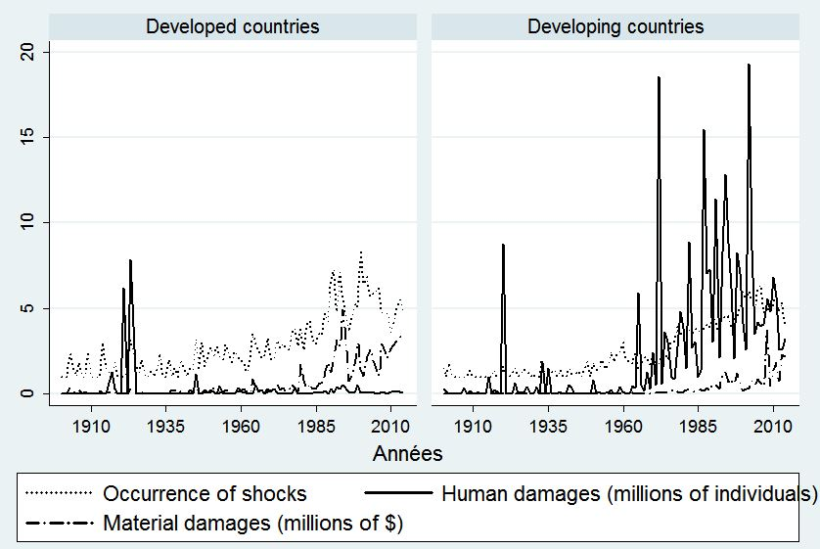

Sources: EM-DAT, World Bank Development Indicators.

The figure 2 reinforces the idea that the damages are relatively high in developing countries because it appears that the human costs of these shocks are more important in middle-income countries and low-income countries compared with high income countries.From a geographical point of view, the South Asia region, followed by East Asia and Pacific and then the North America region appear to be most affected in terms of human damages.This result is to relativize because some regions like sub-Saharan Africa have insufficient information on disasters and their consequences (human and material damage).
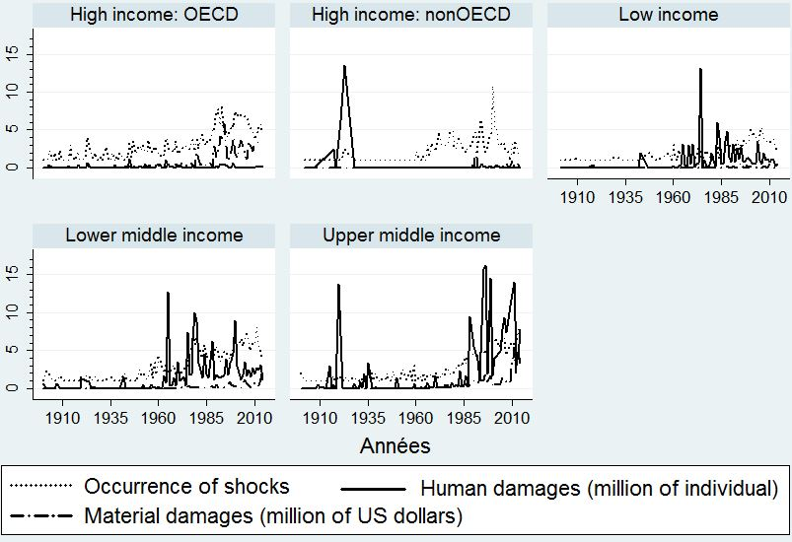
Sources: EM-DAT, World Bank Development Indicators.

Table 1 relates the number of occurrences of the shocks per year and the incidence of poverty in developing countries. A positive relationship is highlighted between the number of occurrences per year and poverty in developing countries.Indeed, the average incidence of poverty is particularly important when the number of annual disasters is high. It goes from 37.8% for the group of countries where shocks occur more than 2 times a year to 65% in the group of countries where the annual number of occurrences exceeds 6. In the group of developed countries, the average poverty incidence varies from 1.9 to 5.3%.

Table 1: Average poverty incidenceby number of occurrences per year and the level of development
Group of countries by number of occurrences per year | Average poverty incidence in developing countries (%) | Average poverty incidencein developed countries (%)
[0;2] | 37.8 | 1.9
[3;5] | 37.4 | 2.4
[6; and over [ | 65.04 | 5.3
Number of countries | 137 | 75
NB: The poverty incidence of the World Bank obtained with the $2.50 per day purchasing power parity threshold.
Sources: EM-DAT, World Bank DevelopmentIndicators.

In addition, the relatively high costs of these disasters have negative consequences on the economic development of countries. They are likely to increase poverty particularly in developing countries. Figure 3 highlights this positive link between the damage from shocks and the poverty incidence in developing countries.

Figure 3: Poverty headcount and total damages of disasters in the developing countries (1960-2014)

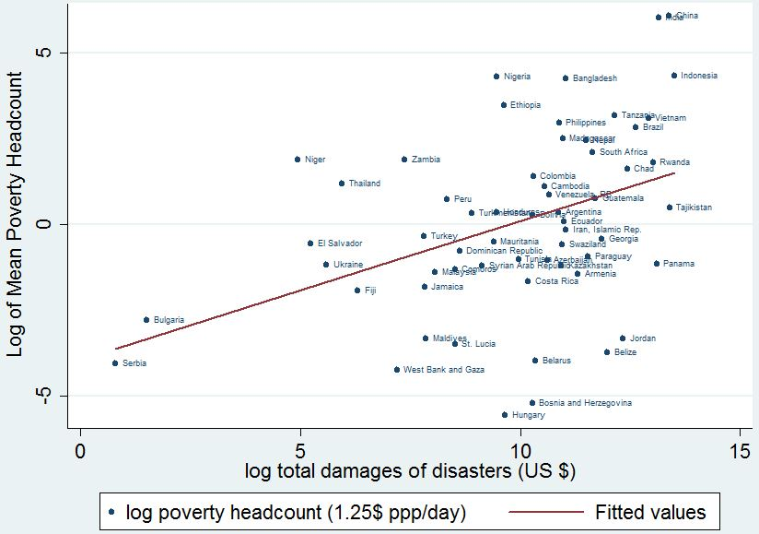
Source : World Bank Indicators.

While the number of disasters have increased, the flows of international migrants and transfers have increased significantly in recent years.The stock of international migrants increased from 76 million in 2000 to 83 million in 2010; an increase of nearly 7 million of migrants in 10 years. Meanwhile migrant remittances to developing countries have increased dramatically from 81 billion US dollars in 2000 to 325 billion US dollars in 2010.

Tableau 2 : International migration and remittances
Year | Stock of international migrant | International remittances
2000 | 76000000 | 81000 000 000
2005 | 77000000 | 192000000000
2010 | 83000000 | 325000000000
Sources : Stock of migrant comes from World Bank Indicators and remittances from « World Bank, migration and remittances factbook 2011 ».

Remittances directly increase the incomes of beneficiary households. They are generally used for current consumption expenditures, spending on housing or physical capital expenditures (Adams, 2005; Adams and Cuecuecha, 2010). They thus improve the welfare of these households. Figure 4 actually shows a negative relationship between remittances and poverty.

Figure 4 : Poverty headcount and international remittances (as % of GDP) in developing countries(1960-2014)
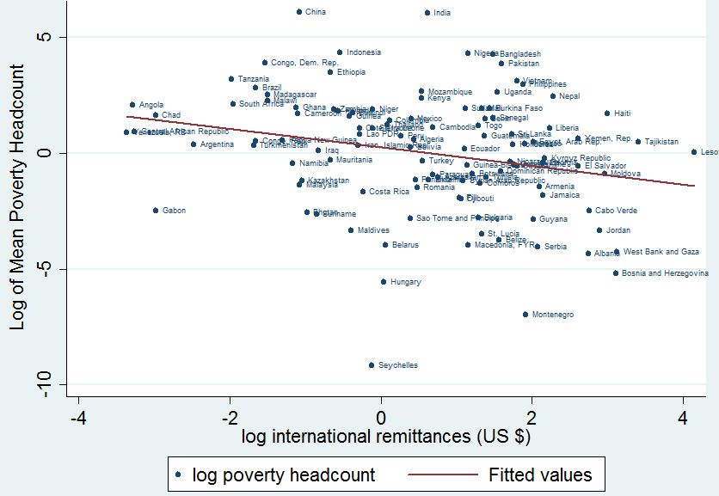
Source : World Bank Indicators.

Figure 5 shows that the international remittances mitigate the damage caused by the disasters and highlighting the resilient nature of these flows. Indeed, the damage decreases as remittances increase.

Figure 5 : Dommage total des désastres et transfert de fonds internationaux (%PIB) dans les pays en développement (1960-2014)
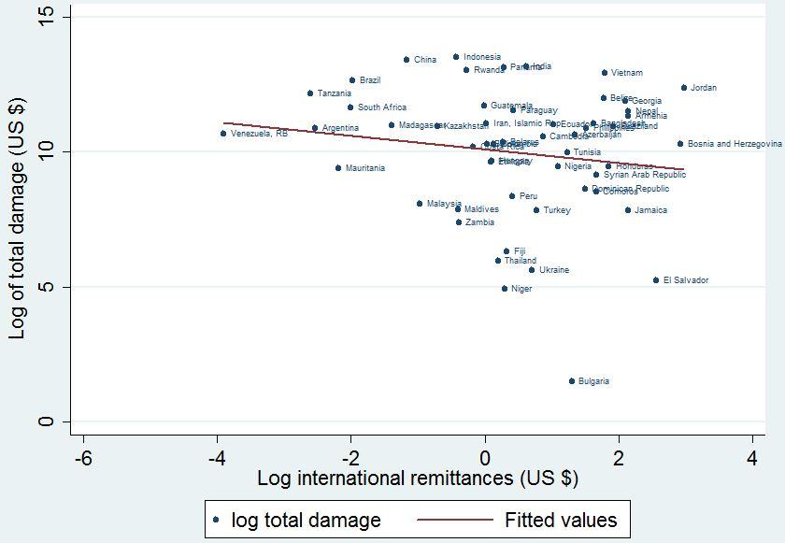
Source : World Bank Indicators.

4.2 Estimations by the GMM method
Only a limited number of countries meet the requirements to construct a credible counterfactual. Moreover, some catastrophes which occur frequently, such as hydrometerological disasters, merit particular attention. A less restrictive method is needed to take account for a larger number of developing countries. The table 2 below presents the results of estimations from a series of models which account for a specific set of disasters. The dependent variable is the logarithm of the poverty incidence. All of the models are estimated by the system-GMM estimator with the robust option. The Arellano-Bond (AR(1)) autocorrelation test is accepted for all models. That of the AR(2) test is rejected for all models. These results confirm the good specification of different models. The Sargan and Hansen tests validate the instruments.

The first model (1) estimates the impact of the shocks on the incidence of poverty via the damages they cause. These are expressed as a percentage of GDP and the resulting ratio is expressed in logarithmic form. The second model (2) used takes the logarithm of the number of persons affected as an indicator variable of the magnitude of shocks. Introducing the lagged variable of poverty incidence enables us to interpret the coefficient of other variables as short-term effects.In the short term, the first model shows that the impact of damages on the poverty incidence is positive. An increase in damages equivalent to 1% of GDP leads to a nearly half-percentage point increase in the poverty rate. Furthermore, the incidence of poverty is significantly lower in Europa, East Asia and North Africa than in Sub-Saharan Africa.
The second model shows that a 1% increase in the number of persons affected by the shock increase the poverty incidence by 0.00454percentage points. This very weak impact compared to the impact of damages can be explained by the fact that destruction of household assets directly impacts their income per capita, while persons may be affected (directly) without their assets or human capital being destroyed to a significant extent. Moreover, the number of persons affected in the previous year does not significantly impact the present poverty incidence.

The third model estimates the impact of the number of persons affected by an epidemic on the poverty incidence. A 1% increase in this number in the preceding year increases the present poverty rate by 0.0239 percent. In fact, epidemics affect the income of victim households via three channels. The first is an increase in health expenditures relative to other lines of spending. This growth, in the absence of additional resources such as transfers, pushes vulnerable households to consume future income by going into debt. Their consumption declines in the following year and some vulnerable households will have expenditures below the poverty line. The second channel is the level of economic activity in localities affected by the epidemic. In the presence of an epidemic, a locality may not only see its economic activity paralysed, but may also be quarantined. Current and future incomes of households therefore decline. The third channel is the destruction of human capital by the epidemic. In effect, the epidemic may take one or more persons in the household out of economic activity for good. In this case, the impact of the epidemic on poverty may be weak or nil in the first year and then become greater in following years.

The fourth model deals with the impact of storms on the poverty incidence. The number of storms and its square are used as indicator variables of the intensity of this type of catastrophe. The coefficients of these two variables are significant but have opposite signs, which suggest that the effect of storms is not monotonic. Destruction caused by heavy rains are countered byagricultural production and greater availability of pastureland for livestock. The fifth and sixth models evaluate the impact on poverty, respectively of drought and insect infestations. The results of the estimation turn up a positive impact of each of these two types of catastrophes on the incidence of poverty. The transmission channel of these shocks is a decline in agricultural productivity. Insect infestations destroy agricultural production as well pastureland. The impact of drought is greater in Sub-Saharan Africa than in other regions in the developing world.

The literature review showed that the impact of disasters can be mitigated or exacerbated by some factors. We first use the level of development measured by GDP per capita. The lower the level of development of a country, the greater is the effect of disasters on poverty incidence.In the six models, this variable is negatively correlated to the poverty incidence. We then introduce remittances in the different models. More important are the transfers, the greater the reduction in the incidence of poverty. For all models, the impact is significant statistically and negative.
Finally we consider income inequality as a factor likely to amplify the impact of disasters on poverty. Measured by the Gini index, inequality increases significantly the poverty incidence.

Dependent variable log(poverty incidence)
 | (1) | (2) | (3) | (4) | (5) | (6)
Lagged log (poverty incidence) | 0.591*** | 0.906*** | 0.854*** | 0.879*** | 0.864*** | 0.773***
 | (3.84) | (31.14) | (28.26) | (18.72) | (27.01) | (11.82)
log(damages) | 8.263*
 | (1.79)
Forward(log(remittences)) | -0.174**
 | (-2.23)
Log(Remittences) |  |  | -0.0520** | -0.0511** | -0.0390** | -0.104***
 |  |  | (-2.53) | (-2.51) | (-2.62) | (-2.79)
log(GDP) | -0.528** | -0.134*** | -0.219*** | -0.165** | -0.181*** | -0.288***
 | (-2.34) | (-3.41) | (-4.51) | (-2.59) | (-4.58) | (-3.44)
log(affected persons) |  | 0.00454**
 |  | (2.01)
Lagged log(number of affected persons) |  | -0.000283
 |  | (-0.25)
log(Gini index) |  | 0.244*** | 0.343*** | 0.283*** | 0.332*** | 0.331**
 |  | (2.97) | (4.11) | (3.61) | (4.47) | (2.37)
log (number of catastrophes) |  | -0.0643**
 |  | (-2.32)
log(number of persons affected by the epidemics) |  |  | 0.0239*
 |  |  | (1.70)
log(number of persons affected by the epidemics) |  |  | -0.0188
 |  |  | (-0.65)
log(number of storms) |  |  |  | 0.0863
 |  |  |  | (0.62)
Log( number of extreme temperatures) |  |  |  | -0.114
 |  |  |  | (-0.61)
Number of droughts |  |  |  |  | 0.0107**
 |  |  |  |  | (2.04)
Sub-Saharan Africa |  |  |  |  | 0.0939
 |  |  |  |  | (1.58)
log(number of insect infestations) |  |  |  |  |  | 0.0725**
 |  |  |  |  |  | (2.22)
Asia | -0.147
 | (-1.05)
Europa | -0.484*
 | (-1.89)
Latina America | 0.0476
 | (0.38)
Middle East & Noth Afri. | -0.423**
 | (-2.11)
South Asia | 0.0173
 | (0.20)
Constant | 5.638** | 0.407 | 0.890** | 0.609 | 0.539** | 1.774
 | (2.49) | (1.53) | (2.17) | (1.17) | (2.24) | (1.63)
Number of obervations | 1879 | 2499 | 1938 | 1938 | 1938 | 1944
Numberof countries | 97 | 97 | 97 | 97 | 97 | 97
ar1p-value | 0.0035 | 0.0000 | 0.0001 | 0.0002 | 0.0002 | 0.0002
ar2 p-value | 0.341 | 0.396 | 0.370 | 0.396 | 0.381 | 0.126
Number of instruments | 21 | 514 | 301 | 278 | 228 | 302
Sarganp-value | 0.0140 | 0.0000 | 0.0000 | 0.0000 | 0.165 | 0.0000
Hansenp-value | 0.221 | 1 | 1 | 1 | 1 | 1

Table3: Effects of catastrophes on poverty incidence in developing countries (t-statistics in parentheses)
+ p<0.1, * p<0.05, ** p<0.01, *** p<0.001
Conclusion
Researchon the macroeconomic effects of major catastrophes tends to show that they do not affect long-term GDP growth (Noy, 2009). But we should not conclude that this necessarily implies that there are no impacts on the incidence of poverty. Abadie et al. (2010) put forward the hypothesis that the absence of long-term effects on per capita income is due to the fact that reconstruction is financed by either a decrease in consumption or by taking on debt. But they did not examine the effects of these two funding methods. In the first case, the negative impact on the incidence of poverty is immediate. In the second case, fiscal revenues drawn from economic growth serve to repay debt but do not reduce poverty, with the ultimate result of a higher poverty rate. Moreover, the effects of catastrophes are greater on poor or vulnerable populations who do not have sufficient assets to counter against risks, or cannot subscribe to insurance. This is why the effects of catastrophes on poverty merit specific attention. The goal of this study was to explore in greater detail the short- and long-term impacts of catastrophes experienced by developing countries on their poverty rates. We have shown the diversity of channels via which disasters may negatively affect livelihoods. These channels have indeed worked. Our results show that catastrophes have a strong and significant impact on the prevalence of poverty. This influence is nevertheless mitigated as the country reaches relatively higher levels of development or when it benefits from international remittances.. The poverty-increasing impact is statistically significant for epidemics, storms and droughts. The impact of droughts on the incidence of poverty, however, is greater in Sub-Saharan Africa than in other regions of the developing world. Remittances have a significant contribution to the reduction of poverty in developing countries. Policies to greater stability of these remittance flows and greater efficiency in the use of resources would accelerate the reduction of poverty and inequality in developing countries. Inequality acts in a direction opposite to that of remittances. They amplify the impact of disasters on the incidence of poverty. Strategies to build resilience to disasters should focus on income generating programs for populations most exposed to droughts, floods, extreme temperatures, etc.Strategies to build resilience to disasters should focus on income generation programs for populations most vulnerable to these shocks.

Bibliography
Abadie, A., A. Diamond, A.J. Hainmueller (2010). Synthetic control methods for comparative case studies: Estimating the effect of California's tobacco control program. J. Am. Stat.Assoc. 105 (490), 493–505.
Abadie, A., A. Diamond andJ. Hainmueller (2014). Comparative politics and the synthetic control method. Am. J. Polit. Sci. http://dx.doi.org/10.1111/ajps.12116 (2014, forthcoming).
Abadie, A. and J. Gardeazabal (2003). The economic costs of conflict: A case study of the Basque Country. Am. Econ. Rev. 93 (1), 113–132.
Akter, S. andB. Mallick (2013). The poverty-vulnerability-resilience nexus: Evidence from Bangladesh. Ecological Economics, 96, 114–124. http://doi.org/10.1016/j.ecolecon.2013.10.008.
Alam, K. andA. Mahal (2014). Economic impacts of health shocks on households in low and middle income countries: A review of the literature. Globalization and Health, 10(1), 21. http://doi.org/10.1186/1744-8603-10-21.
Albala-Bertrand, J.M. (1993a). Political economy of large natural disasters with special reference to developing countries. Oxford: Calendron Press.
Albala-Bertrand, J.M. (1993b). Natural disaster situations and growth: A macroeconomic model for sudden disaster impacts, World Development 21 (9): 1417–1434.
Arellano, M. and S. Bond (1991). Some tests of specification for panel data: Monte Carlo evidence and an application to employment equations. Review of Economic Studies, 58: 277–97.
Arellano, M., and S. Bond (1998). Dynamic Panel data estimation using DPD98 for Gauss: A guide for users.
Arouri, M., Nguyen, C. and Youssef, A.B. (2014). Natural disasters, household welfare and resilience: evidence from rural Vietnam. World development. Vol.70. pp. 59-77.
Asiimwe, J. B. andP. Mpuga (2007). Implications of rainfall shocks for household income and consumption in Uganda. AERC Research Paper 168.
Baez, J. and I. Santos (2007). Children’s vulnerability to weather shocks: A natural disaster as a natural experiment. Working Paper. Available at SSRN : http://ssrn.com/abstract=903684>.
Benson, C. and E.J. Clay (2004). Understanding the Economic and Financial Impacts of Natural Disasters. Disaster Risk Management Series 4. Washington DC: World Bank.
Berloffa, G. andF. Modena (2013). Income shocks, coping strategies, and consumption smoothing: An application to Indonesian Data. Journal of Asian Economics, 24, 158-171.
Blundell, R. and S. Bond (1998). Initial conditions and moment restrictions in dynamic panel data models. Journal of Econometrics, 87: 11–143.
Cannon, T. (2008). Reducing people’s vulnerability to natural hazards: Communities and resilience. Wider Research Paper, 19.
Carter, M. R., P. D. Little, T. Mogues andW. Negatu (2007). Poverty traps and natural disasters in Ethiopia and Honduras. World Development, 35(5), 835–856. http://doi.org/10.1016/j.worlddev.2006.09.010.
Cavallo, E., S. Galiani I. Noy. and J. Pantano (2013). Catastrophic natural disasters and economic growth. Review of Economics and Statistics, 95(5), 1549–1561. http://doi.org/10.1162/REST_a_00413.
Combes, J-L. and Ebeke, C. (2011). Remittances and household consumption instability in developing countries. World development. Vol.39, No. 7. pp. 1076-1089.
Datar, A, J. Liu, S. Linnemayr andC. Stecher (2013). The impact of natural disasters on child health and investments in rural India. Soc Sci Med, 76(1), 83–91. http://doi.org/10.1016/j.socscimed.2012.10.008.
Dercon, S. (2004). Growth and shocks: Evidence from rural Ethiopia. Journal of Development Economics, 74, 309-329.
Dercon, S. and P. Krishnan (2000). In sickness and in health: Risk sharing within households in rural Ethiopia, Journal of Political Economy, 108 (4): 688–727.
El, M., H. Arouri, A. B Youssef, C. Nguyen-viet andM. El Arouri (2014). Effects of urbanization on economic growth and human capital formation in Africa To cite this version :
Felbermayr, G. andJ. Gröschl (2013). Naturally negative: The growth effects of natural disasters. Journal of Development Economics, 111, 92–106. http://doi.org/10.1016/j.jdeveco.2014.07.004.
Folke, C., S. Carpenter, B. Walker, M. Scheffer, T. Elmqvist, L. Gunderson and C.S. Holling(2004). Regime shifts, resilience and biodiversity in ecosystem management. Annual Review of Ecology Evolution and Systematics, 35, 557-581.
Foltz, J., Gars, J., Ozdogan, M., Simane, B. and Zaitchik, B. (2013). Weather and welfare in Ethiopia.Selected Paper prepared for presentation at the Agricultural & Applied Economics Association’s 2013.
Freeman, P. K., M. Keen andM. Mani (2003). Being prepared: Natural disasters are becoming more frequent, more destructive, and deadlier, and poor countries are being hit the hardest. Finance and Development, 40(3), 42-45.
Galderisi, A., A. Ceudech, F. F. Ferrara andA. S. Profice (2010). Integration of different vulnerabilities vs. natural and na-tech hazards, ENSURE Project, Deliverable 2.2.
Giesbert, L. andK. Schindler (2012). Assets, shocks, and poverty traps in rural Mozambique. World Development, 40(8), 1594–1609. http://doi.org/10.1016/j.worlddev.2012.04.002.
Hallegatte, S. and V. Przyluski (2010). The economics of natural disasters. Concepts and methods. World Bank Policy Research Working Paper 5507. Washington DC: World Bank
Hendrix, C. S. andI. Salehyan (2012). Climate change, rainfall, and social conflict in Africa. Journal of Peace Research, 49(1), 35–50. http://doi.org/10.1177/0022343311426165.
Hoddinott, J. and B. Kinsey (2001). Child health in the time of drought. Oxford Bulletin of Economics and Statistics, 63: 409–436.
International Panel on Climate Change (IPCC). 2007. Summary for policymakers.
Jakobsen, K. (2012). In the eye of the storm: The welfare impacts of a hurricane. World Development, 40, 2578-2589.
Kazianga, H. and C. Udry (2006). Consumption smoothing? Livestock, insurance and drought in rural Burkina Faso.Journal of Development Economics, 79, 413–446.
Kellenberg, D. K. and A.M. Mobarak (2008). Does rising income increase or decrease damage risk from natural disasters? Journal of Urban Economics, 63(3), 788–802. http://doi.org/10.1016/j.jue.2007.05.003.
Kelly, J., B. Marshall andG. Erick (2012). Income shocks and HIV in Africa, (39944).
Lassage, R., Veldkamp, T.I.E., De Moel, H., Van, H.L., Vellinga, P. and Aerts, J.C.J.H. (2014). Assessment of the effectiveness of flood adaptation strategies for HCMC. Natural Hazards and Earth System Sciences.
Lazzaroni, S. (2013). Economics of natural disasters: From macro- to micro- evidence with a focus on developing countries.Universita Cattolica Del Sacro Suore Milano.
Lazzaroni, S. andP. A. G. Bergeijk (2013). Natural disasters impact, factors of resilience and development: A meta-analysis of the macroeconomic literature. ISS Working Paper Series/General Series, (554). http://doi.org/10.1016/j.ecolecon.2014.08.015.
Maccini, S.L. and D. Yang (2008). Under the weather: Health, schooling, and economic consequences of early-life rainfall, NBER Working Paper 14031. Cambridge, MA: NBER.
Mechler, R. (2009). Disasters and economic welfare: Can national savings help explain post disaster changes in consumption? Policy Research Working Paper No. 4988) Retrieved from World Bank website: http://econ.worldbank.org/WBSITE/EXTERNAL/EXTDEC/ EXTRESEARCH/0,,menuPK:469435~pagePK:64165236~piPK:64165141~theSitePK:46 9382,00.html.
Mohapatra, S., G. Joseph andD. Ratha (2012). Remittances and natural disasters: Ex-post response and contribution to ex-ante preparedness. Environment, Development and Sustainability, 14(3), 365–387. http://doi.org/10.1007/s10668-011-9330-8.
Morris, S., O. Neidecker-Gonzales, C. Carletto, M. Munguia, J. M. Medina andQ. Wodon (2002). Hurricane Mitch and the livelihoods of the rural poor in Honduras. World Development, 30, 49-60.
Mueller, V. A. andD. E. Osgood (2009a). Long-term consequences of short-term precipitation shocks: Evidence from Brazilian migrant households. Agricultural Economics, 40(5), 573–586. http://doi.org/10.1111/j.1574-0862.2009.00399.x.
Mueller, V. A.and D. E. Osgood (2009b). Long-term impacts of droughts on labour markets in developing countries: Evidence from Brazil. Journal of Development Studies, 45(10), 1651–1662. http://doi.org/10.1080/00220380902935865.
Mueller, V. andA. Quisumbing (2011). How resilient are labour markets to natural disasters? The case of the 1998 Bangladesh flood. Journal of Development Studies, 47(12), 1954–1971. http://doi.org/10.1080/00220388.2011.579113.
Narayan, P. (2003). Macroeconomic impact of natural disasters on a small island economy: evidence from a CGE model. Applied Economics Letters, 10, 721-723.
Noy, I. andT. B. Vu (2010). The economics of natural disasters in a developing country: The case of Vietnam. Journal of Asian Economics, 21(4), 345–354. http://doi.org/10.1016/j.asieco.2010.03.002.
Rasmussen, T. N. (2004). Macroeconomic implications of natural disasters in the Caribbean. IMF Working Papers, 04(224), 1. http://doi.org/10.5089/9781451875355.001
Rodríguez-Oreggia, E., A. de la Fuente andR. de la Torre (2008). The impact of natural disasters on human development and poverty at the municipal level in Mexico. United Nations Development Programme Regional Bureau for Latin America and the Caribbean, (August 2014), 1–27. http://doi.org/10.1080/00220388.2012.700398.
Roodman, D. (2009). How to do xtabond2: An introduction to difference and system GMM in Stata. Stata Journal, 9 (1), 86.
Rush, J. V. (2013). The impact of natural disasters on poverty in Indonesia. University of Hawaii, (November), 1–42.
Sawada, Y. and S. Shimizutani (2008). How do people cope with natural disasters? Evidence from the great Hanshin-Awaji (Kobe) earthquake in 1995. Journal of Money, Credit, and Banking, 40, 463-488.
Shoji, M. (2010). Does contingent repayment in microfinance help the poor during natural disasters. Journal of Development Studies, 46, 191-210.
Strobl, E. (2012). The economic growth impact of natural disasters in developing countries: Evidence from hurricane strikes in the Central American and Caribbean regions. Journal of Development Economics, 97(1), 130–141. http://doi.org/10.1016/j.jdeveco.2010.12.002.
Thanh, N., H. Hang, N. Chuc, N. Rudholm, A. Emmelin andL. Lindholm (2006). Does “the injury poverty trap” exist? A longitudinal study in Bavi, Vietnam. Health Policy, 78, 249-257.
Thomas, T., L. Christianensen, Q. T. Do andL. D. Trung (December 2010). Natural disasters and household welfare: Evidence from Vietnam. World Bank,. http://doi.org/10.1016/j.worlddev.2014.12.017.
Tiwari, S., H. Jacoby andE. Skoufias (March 2013). Monsoon babies.Rainfall shocks and child nutrition in Nepal. World Bank Policy Research Working Paper, 6395.
Van den Berg, M. (2010). Household income strategies and natural disasters: Dynamic livelihoods in rural Nicaragua. Ecological Economics, 69(3), 592–602. http://doi.org/10.1016/j.ecolecon.2009.09.006.
Vos, R., M. Velasco and E. de Labastida (1999). Economic and social effects of El Niño in Ecuador, 1997-1998. Inter-American Development Bank Technical Paper POV-107. IADB: Washington DC.
Wong, P. Y. andP. H. Brown (2011). Natural disasters and vulnerability: Evidence from the 1997 forest fires in Indonesia. The B.E. Journal of Economic Analysis & Policy, 11(1). http://doi.org/10.2202/1935-1682.2658.
Yousefpour, R., Didion, M., Jacobsen, J.B., Meilby, H., Hengeveld, G.M.,Schelhaas, M-J. and Thorsen, B.J. (2015). Medelling of adaptation to climate change and decision-makers behaviours for the Veluwe forest area in the Netehrlands. Forest Policy and Economics.
Zapata-Marti (1997).Methodological approaches: The ECLAC methodology, in Center for the Research on the Epidemiology of Disasters (CRED), Assessment of the economic impact of natural and man-made disasters: 10-12. Proceedings of the expert consultation on methodologies, Brussels, 29–30 September. Belgium: Université Catholique de Louvain.

